Learning Outcome 2 - Explain Project Management Concepts

# 2.1 Explain projects and ongoing operations

The terms "project" and "operation" are often used in the same context, but actually have very different meanings.

## Defined Process (Baking a cake)

* A linear process when given the same inputs will produce the same outputs.
* The process and its results are planned in detail ahead of the operation
* Doesn’t require background knowledge in the area of the activity being performed assuming the process is defined well.

## Empirical Process (Operating an unfamiliar shower)

* A process where not all the actions and reactions are known ahead of time.
* Progress is made by changing aspects of the process and observing the results. The observations are used to inform future changes.
* Background knowledge in the area of the activity being performed is required in order to make informed decisions about how to tune the process.

## Projects

An empirical process – it has a known end goal and some known constraints for achieving that goal. The steps needed to achieve that goal are not known in detail. A project will likely consist of multiple interdependent activities which are used to move towards the end goal.

According to the PMBOK (Project Management Body of Knowledge), a Project has the following properties:

**Temporary** – has a start and end date.   
 **Goal/objective oriented** – is finished when goals/objectives have been completed or cannot be accomplished.  
 **Can be unique** – (or at least unique for that organization) where the work being conducted hasn’t been performed previously.

**Focused** – The task of the project is to deliver a particular product, service or result.

* Product - component of another item, an item enhancement, or the end item. (software)
* Service – capability to perform a service. (a new business function
* Result – usually an outcome (like a document). So it could be something that is a result of research.

**Integrated** – require the work of a group of people with different knowledge sets to work together to accomplish the goal/objective. (larger projects usually will include different groups of people – project managers, analysts, designers, programmers, technical writers, area experts (ie: if a financial application was needed, experts in finance would be required.)

**Emergent** – Sometimes work needs to be completed prior to obtaining a clear idea of how to achieve the results and how. This is considered emergent.

**Social** – projects usually contain multiple project members (however, some small projects may only include 1 person). The tasks they carry out are completed for clients. (example: Kevin installing new servers – only included himself but was still social because he had to deal with vendors)

**Has an outcome and deliverables** – this outcome is usually have some form of lasting outcome (ie: the product/service/result). This outcome could be tangible or intangible (meaning something you can touch)

**A number of activities are undertaken to solve a problem**

## Operations

Is considered a defined process. It is a set of defined steps, with known inputs and known outputs. Operations are repetitive and ongoing (They will not have a defined end date).

An operation has these properties:

* Involves continuous and repetitive work
* No end date
* Work follows existing procedures
* Purpose is to sustain the business and/or maintain operations
* Usually the operations produce the same product or result

# 2.2 - Define common terms in project management

## Project Management

Project management is the application of knowledge, skills, tools, and techniques to project activities to meet the project requirements. Project management includes processes like:

* Initiating,
* Planning,
* Executing,
* Monitoring and Controlling, and
* Closing.

Managing a project typically includes, but is not limited to:

* Identifying requirements;
* Addressing the various needs, concerns, and expectations of the stakeholders in planning and executing the project;
* Setting up, maintaining, and carrying out communications among stakeholders that are active, effective, and collaborative in nature;
* Managing stakeholders towards meeting project requirements and creating project deliverables;
* Balancing the competing project constraints, which include, but are not limited to:
  + Scope,
  + Quality,
  + Schedule,
  + Budget,
  + Resources, and
  + Risks.

## Project Management Terms

* **Goal** – The final desired result, product/service
* **Task** – a combination of activities that lead to the achievement of a definable result.
* **Activity** – a distinct, scheduled portion of work performed during the course of a project.
* **Duration** – the elapsed time from the beginning to the end of an objective, activity or task.
* **Scope** – specifies what the project involves. It is the work that will be performed in order to deliver the product/service/result.
* **Stakeholder** – individuals or organizations that are actively involved in the project, or whose interests may be positively or negatively affected as a result of the project execution or completion. They may also exert influence over the project and its results.

# 2.3 - Explain roles and characteristics of a project team

Organizational structure is a factor which can greatly affect a project's availability or resources and influence how projects are lead. Organizational structures can be either functional, projectized or a varying combination of both.

## Functional (Horizontal) Organization Structure

* Each employee involved will have one clear superior.
* Employees are typically grouped into departments by specialty (Ex. Systems Admins, Programming, HR, Finance, etc)
* Each department works on a project independently of other departments, with limited points of collaboration.

## Projectized (Vertical) Organization Structure

* Team members are often co-located for the duration of the project.
* Each team is often focused on a single project
* Project managers have a high level of control and freedom.
* Employees are grouped into departments, but will work with their respective teams.
* Departments can either report directly to the manager of the project or provide support services to various projects.

## Roles

### Development team members

* Development team members are the people who will design, implement, test and deploy the project
* Expected to come from a wide variety of backgrounds
* Team members have "T shaped" skills
  + Not a jack of all trades, but also not a single skilled specialist
  + A broad set of knowledge, but a depth of knowledge in certain areas
  + This is reinforced by working on a cross-functional team

### Product owner

Someone who acts as a “client proxy” can help to keep agile teams focused on the customer vision. Product owners help reduce downtime waiting for customer responses.  
  
Product owners perform the following:

* Act as the voice of the customer
* Responsible for maintaining a cohesive product vision
* Re-prioritizes release and iteration goals
* Final say on requirements questions
* Decides whether to continue development
* Considers stakeholder interests and weighs them against team reality
* May contribute as a team member, but more often acts as a product owner to multiple teams
* Has a leadership role, often comparable to a traditional project manager

### Project manager

The project manager is an individual assigned by the performing company to oversee that the objectives of the project are met.

Project Managers:

* may have to report to other managers higher up in the organization.
* may or may not be the direct supervisor of persons on the team.

### Agile Product Teams

The agile approach to software development emphasizes a sort of projectized, or vertical team, where team members have different skill sets which mesh together to form a cohesive unit.

Agile teams are often said to have these properties:

#### Self-organizing

* The team controls their working conditions, organizational structure and way of doing things.
* Often referred to as an “emergent” organizational structure. The team decides on the most appropriate way to get their work done.

#### Cross functional

* Agile teams consist of members from each level of the software development process
* Agile projects perform traditionally serial development operations in parallel (especially testing).

#### Focused

* Teams which work on either a single or only a very small number of projects tend to be more productive.

#### Sustainable

* Agile development puts a great deal of focus on creating working conditions where team members can work at a sustainable pace.

#### Long-lived and cohesive

* Agile works best with teams not groups
* Long lived, co-located smaller teams tend to have more rapid transparent internal communication, as team members get used to the way each other thinks.
  + Communication is “hot”, high bandwidth
* (Cohn 2009) Having small teams helps keep teams efficient
  + Less social loafing
  + Increased constructive interaction
  + Decreased time spent coordinating
  + Small teams are more socially satisfying
  + Overspecialization is less likely to occur

Video – Introduction to Scrum

<http://youtu.be/D8vT7G0WATM>

### Scrum Master

- facilitates the group

-removes distractions

- not a manager

-answers questions and teaches team members about the agile process.

-interaction among members in a group/meeting:

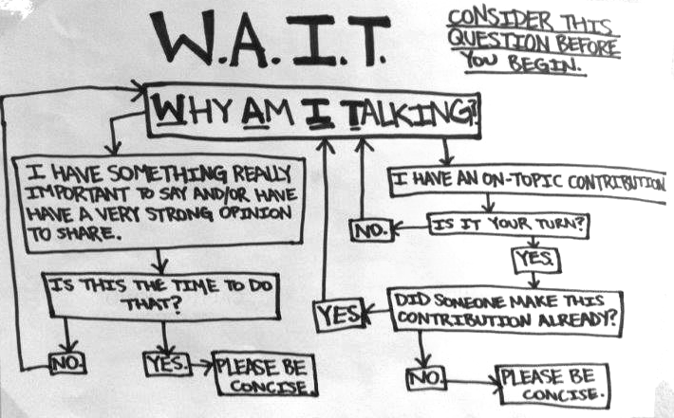

# 2.4 - Explain the importance of client/project team collaboration

The main goal of Agile software development is to help software development teams respond to change.

Change is a constant and is expected in software projects. The most important changes a project team deals with are changes to their clients’ requirements. There is likely to be change involved in the specifics of certain requirements, as well as to major future functionality.

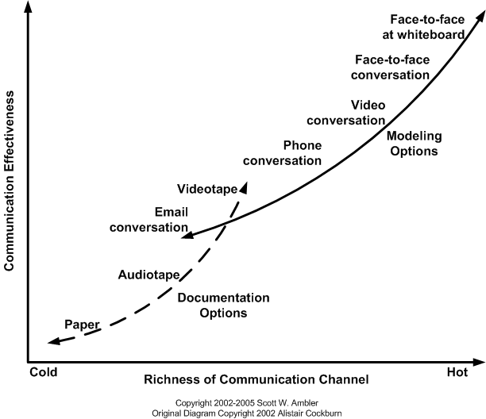

Change is a frequent occurrence so the richness of communication between the client and the team is an essential factor in creating an efficient project workflow. The above diagram, from the book "Disciplined Agile Delivery" by Scott Ambler and adapter from the original by Alistair Cockburn, describes a variety of communications techniques commonly used by project teams.

## Cold (Low bandwidth) communication techniques

On the bottom left are "cold", or "low bandwidth" communication techniques.

Examples: Paper, Audio tape, Video tape

These techniques:

* Are typically one-way
* Have slow feedback cycles
* Have few parallel communication channels.
* Often do not invite or encourage immediate responses or feedback/discussion,
* Are often not well suited to dealing with rapid change

## Hot (High bandwidth) communication techniques

Towards the top right are "hot", or "high bandwidth" communication techniques.

Examples: email, phone/video conversations, face-to-face meetings

These techniques:

* Are fast
* Are a multipathed communication method
* Involve people using many different ways of communicating simultaneously, which often leads to more efficient communication of ideas.
* Tend to be less “permanent” than Cold techniques,
* Need more effort spent on documenting results of Hot communication than Cold.

Further reading:

<http://www.agilemodeling.com/essays/communication.htm>

# 2.5 - Examine common meeting and reporting procedures

Generally a meeting is held for:

1. Exchanging information
2. Brainstorming, option evaluating, and/or Designing
3. Decision making

## Ad hoc or Side bar meeting

Meetings to address specific issues that arise over the course of the project. Usually very short, and scheduled to separate specific discussion of a topic from another meeting in order to help keep other meetings on track.

## Client or Stakeholder meetings

Client or stakeholder meetings can be a regular occurring meeting or an ad hoc meeting. Could be used for providing updates on the project, solving issues and/or obtaining clarification. These are often held at the end of each sprint (sprint can be 1, 2 or 3 weeks long).

### Kickoff meeting

This is the first meeting that the client and project team have together to officially start the project. Topics usually cover introductions, Schedules, Status reporting, Risks, discussions on any legalities. Also functions as an initial requirements-gathering exercise.

### Client Meeting

The entire purpose of a client meeting, or any meeting really, is to exchange information. In the case of a client meeting, the purpose is usually twofold

* The team needs to gain a better understanding of the client’s needs.
* The client needs to see what the team has produced in order to provide feedback.

The outcomes of a client meeting are usually two things

* Clarify or develop new requirements
  + Project team must document these requirements
* Action items
  + Action items should have a defined “responsible person” as well as a deadline to complete the item. It needs to be written down to prevent it from being forgotten.

#### Client Meeting terms:

Agenda – An outline of items to be discussed and the order to discuss the items. Each item listed should indicate who is responsible for presenting or driving the item.

Meeting Chair/Chairperson- person responsible for keeping track of the amount of time remaining for the meeting, keeping discussions on topic, and keep the meeting flowing from one agenda item to the next.

Meeting minutes – document the action items and other outcomes of a project meeting.

Most important elements of meeting minutes are to capture:

* Requirements – either new or changed
* Action items – items that need to be completed by a specific person by a specific date.

Minute taker – Someone assigned to take the meeting minutes. They ensure that they have all the information needed for the action items (who/what/when). All team members should take some form of minutes to ensure that requirements are captured. The minute taker is responsible for ensuring that the team notes are collated into a single document. They are also responsible for ensuring that those who were invited to the meeting receive a copy of the minutes.  
  
Meeting Minute Review – this is provided at the end of the meeting by the Minute taker

* It is short and concise – and IS NOT an exact play-by-play, he said this then she said this. A summary of each stage is fine
* Cover the highlights - specifically mention each new or updated requirement discovered during the meeting
* Cover the action items - who, when and what

## Regular team meetings

Regular team meetings for persons working on various aspects of a project. In Agile, these would be the daily standup and retrospective meetings.

### Standup meetings

The standup meeting, also sometimes called the "scrum meeting" or daily huddle, is an essential part of an agile development process. In a standup meeting, teams decide on a specific time, usually first thing in the morning, where the team will meet for a very short (<15 minute) time where each team member will discuss three specific topics:

* What I did yesterday? What project-related features/stories/research you did during the previous work day.
* What I will do today? This could be a continuation of previous work or new work that you will take on today.
* What impediments do/did you have? Anything that is holding up progress for you.

This video, provided by CollabNet free of charge, describes the process of an agile team working through their daily standup meeting.

<http://scrumtrainingseries.com/DailyScrumMeeting/DailyScrumMeeting.htm>

### Retrospective

The retrospective meeting is the final stage of an Agile iteration. It gives the team a chance to be introspective - to review and learn from how they work.

In a retrospective meeting, the team attempts to answer 4 questions:

1. What went well in the last iteration? Things the team should do more often.
2. What did NOT go well in the last iteration? Things the team should do less often.
3. What questions does the team have? These can be questions for the client, team members, or about the company as a whole. Anything that the team needs to know in order to work more efficiently.
4. What do we need to act on? These are actions the team needs to take in order to fix any problems they’ve identified. Ensures that good practices are continued and answers any questions.

This video, provided again by CollabNet for our use, describes a set of methods for creating an effective introspective team.

<http://scrumtrainingseries.com/SprintRetrospectiveMeeting/SprintRetrospectiveMeeting.htm>